
电脑指导追溯多品种小比例配料秤简介
功能：电脑接收生产计划，指导操作人员依序计量，不按规定顺序，规定量计量，配料秤不工作。提高配料精度，防止人为错误发生。生产计划配方，生产批次可通过网线在品控室输送，追溯生产过的配方，计量精度。设定密码，非操作人不能使用。
最大秤量：60kg，精度：10g，台面420*520mm
触控平板电脑、PPC-P150-V，显示器尺寸370*284mm
电压：200-240V（配1kw稳压器一台）
储存配方数：无限个。每个配方品种：无限个。生产信息：无限个。
平板电脑点击寿命：3500万次
工作原理：打开电源开关，启动电脑，屏幕显示下达生产通知单。点击显示生产品种配方，每个品种配方生产批次。开始生产点击第一个品种配方，显示配方各小比例原料名称、配料量。点击第一个小比例原料，操作人员上料计量。量不足显示黄色，超量显示红色，标准量显示绿色，绿色完成计量，拿下计量袋。按品种转换按钮，转下一品种计量，依次完成一批次计量。点击电脑生产同一配方，下一批次。同一配方完成计划批次后，点击转生产下一品种配方。前一配方自动删除。
生产过程：每一配方，每一笔计量自动存入电脑，随时可以追溯。
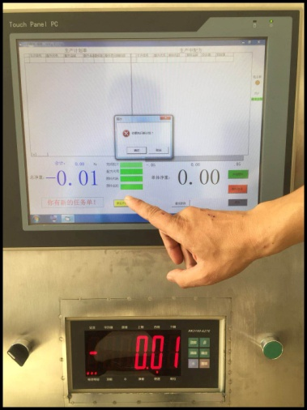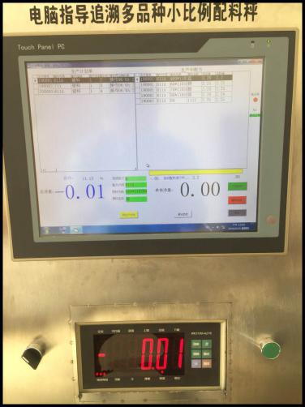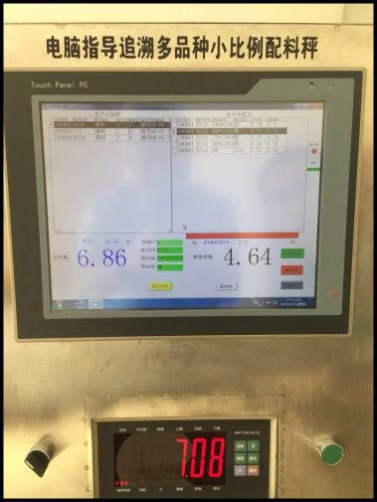
生产通知单 生产计划单和生产配方 超量显示红色
量不足显示黄色

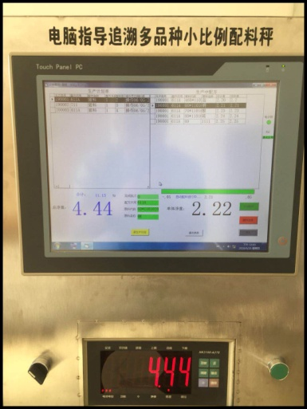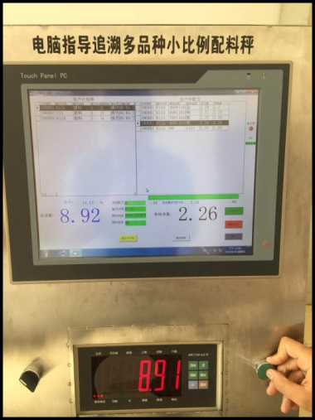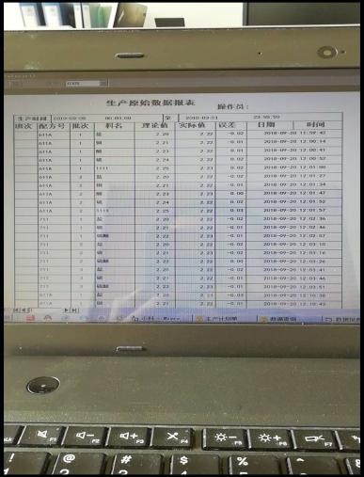

标准量显示绿色 完成计量按品种转换按钮 生产原始数据报表

Brief introduction of computer guidance traceability
multi variety small scale batching scale
Function: The computer receives the production plan, instructs the operator to measure according to the order, does not measure according to the prescribed order, the prescribed quantity measurement, the batching scale does not work.Improve batching accuracy and prevent human errors.Production planning formula, production batches can be transported through wire in the quality control room, tracing the formula produced, measurement accuracy. Set password, non operator can not use.
Maximum weight: 60kg, accuracy: 10g, mesa 420*520mm.
Touch panel PC, PPC-P150-V, display size 370*284mm.
Voltage: 200-240V (with 1kW regulator).
Storage formula, unlimited. Each formula, unlimited. Production information,Unlimited.
Tablet life hits 35 million times.
Working principle, turn on the power switch, start the computer, and the screen shows the production notice.Start production and click on the first variety formula, showing the small proportion of ingredients and the amount of ingredients. Click on the first small proportion of raw materials, the operator feeding measurement.The quantity is not enough to show yellow, the excess is red, the standard quantity is green, the green completes the measurement, takes down the measuring bag.According to the variety conversion button, the next metering is carried out, and a batch of measurement is completed sequentially.Click on the computer to produce the same formula, the next batch.After finishing the batch plan with the same formula, click the next production formula. The previous recipe is automatically deleted.
Production process: each prescription, each measurement automatically stored in the computer, can be traced at any time.
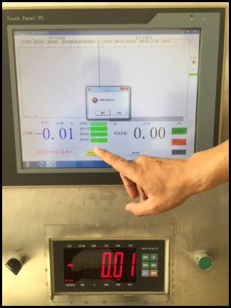

Production notice Production plan and production formula Over display red
Insufficient quantity to show yellow.
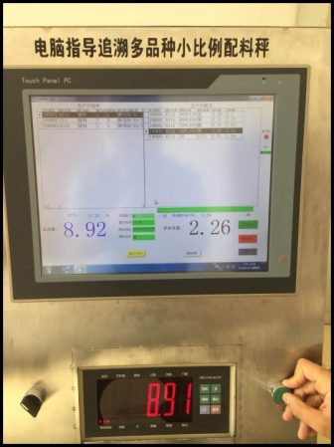
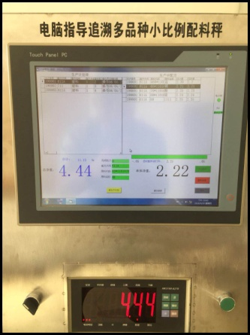

Standard quantity shows green. Complete the conversion Production of raw data report
button according to the variety.

